Medically Generated Brain Tumor Report Using Deep Learning Is Sent Via Mail Using Efficient SMTP
Mr. Bhaskar Mekala^{1*}, Dr. Neelamadhab Padhy² ,Dr. P. Kiran Kumar Reddy³
^{1*} Research Scholar, Department of Computer Science Engineering, GIET University, Gunpur, Odisha, India, bhaskar.mekala@giet.edu
² Professor, Department of Computer Science Engineering, GIET University, Gunpur, Odisha. India.
dr.neelamadhab@giet.edu
³Professor, Department of Computer Science Engineering, MLRIT, JNTUH, Hyderabad, Telangana.India.
kiran.penubaka@gmail.com

ABSTRACT
Deep Tumor is a brain tumor segmentation and classification article aimed at developing a deep learning model with over 1 million parameters using Tensor Flow. Our model will be powered by fresh data images and optimized for accuracy and efficiency. We will employ green computing practices to ensure that our model contributes to Sustainability. One of the key features of Deep Tumor is the development of a User Interface that enables easy interaction with the model. Users will be able to input patient details, and within seconds, the system will generate reports on tumor detection and classification. These reports will be delivered via email or SMS for user convenience. Our article will be an effective and efficient tool for healthcare professionals to improve the diagnosis and treatment of brain cancers. The high accuracy and efficiency of our deep learning model will ensure that patients receive timely and accurate information, leading to better patient outcomes. We believe that our focus on sustainability combined with the latest deep learning technology will make Deep Tumor a valuable and innovative contribution to the healthcare field.
Keywords: Deep Tumor, accuracy, segmentation, classification, healthcare, deep learning model

- Introduction
Artificial intelligence (AI) is one of the most promising approaches to health invention. The use of AI in image recognition vastly extends findings beyond the constraints of mortal sight. The operation of AI in medical imaging, which relies on picture interpretation, is salutary for automatic opinion. The problem of detecting brain excrescences at an early stage is well advanced with convolutional neural network (CNN) and deep literacy algorithms (DLA).
The advancement of artificial intelligence (AI) and machine learning (ML) has opened up new possibilities in the field of medical diagnostics. One place wherein those technologies have shown amazing capability is within the early detection and prediction of cancer. Cancer, being a main motive of loss of life international, requires modern solutions which could aid in its well timed analysis and remedy.
Our goal in this article is to create a web application named "DeepTumor" that uses AI and ML methods to identify brain tumors and forecast the likelihood of developing cancer.

The primary goal of the Deep Tumor article is to provide an on hand and green device for most cancers detection and prognosis. The internet software lets in customers to add brain tumor pictures received through diverse medical imaging techniques, together with magnetic resonance imaging (MRI) or computed tomography (CT) scans.
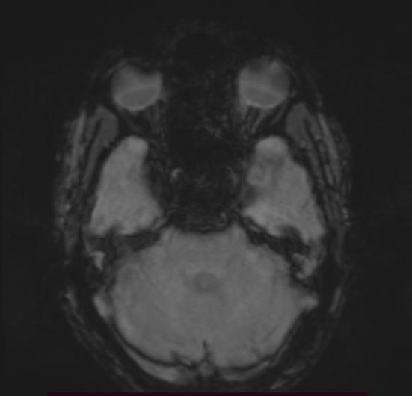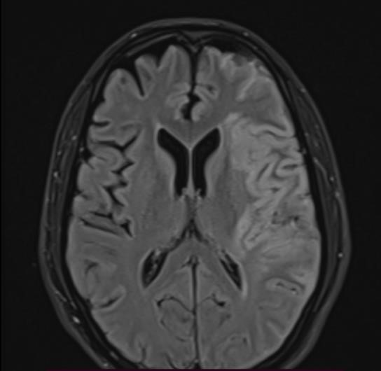
Fig1. MRI images of 39 y/o Sampath taken from ARUNDATHI HOSPITAL, Hyderabad, and Telangana State (17-05-2023).
At the coronary heart of Deep Tumor lies a carefully educated ML version that has learned patterns and traits of tumor images from a numerous dataset. The model employs Convolutional neural networks (CNNs) to extract problematic capabilities from the uploaded tumor photographs. By way of reading those capabilities, the model can correctly identify the presence of tumors. This fact is crucial in figuring out the severity of the circumstance and planning appropriate remedy techniques.
To provide users with comprehensive insights, Deep Tumor generates detailed medical reports that summarize the analysis results. These reports contain essential information such as the patient's name, contact details, and demographic information (All non-clinical information about a patient, such as name, date of birth, address, phone number, email address, sex, race, etc., is referred to as patient demographic data.). Additionally, the reports include the predicted possibility of cancer and any other relevant findings from the image analysis.
With a focus on efforts relating to the applications of computer vision, virtual reality, and robotics to biomedical imaging challenges, Medical Image Analysis offers a venue for the dissemination of new research findings in the field of medical and biological image analysis.
By automating the report generation process, Deep Tumor ensures consistent and reliable documentation, reducing the potential for human error and enabling healthcare professionals to focus more on patient care.
To streamline the report generation and delivery process, Deep Tumor integrates with the Docupilot API. This integration enables the automatic generation of standardized medical reports in a user-friendly format. Once the analysis is complete, the reports are generated with all the necessary details and sent to the respective patients via email. This ensures quick and efficient delivery of the results, allowing patients and healthcare providers to promptly access and reviews the findings.
In conclusion, Deep Tumor aims to revolutionize cancer detection and prediction by leveraging AI and ML techniques. By providing a user-friendly web application, accurate tumor analysis, and comprehensive medical reports, DeepTumor strives to assist healthcare professionals in making timely and informed decisions. This newsletter represents a vast step in the direction of enhancing the efficiency of cancer diagnostics, in the long run leading to advanced affected person outcomes and a higher know-how of the sickness.
II. Related Works
Picture division and characterization is one of the significant errands in AI and it is broad in clinical finding too. Mircea Gurbin, Mihaela Lascu,and Dan Lascu et al. [ 6] proposed a technique comprising of Ceaseless Wavelet Change (CWT), Discrete Wavelet Transform(DWT)andSupportVectorMachine(SVM).
It utilizes various degrees of wavelets, and via preparing, the malignant and non-destructive growths can be distinguished. The calculation time is longer for the proposed strategy.Somasundaram S. and Gobinath R. et al. [7] explains the present status of detection and segmentation of tumour through deep learning models. For more profound division, 3D based CNN, ANN and SVM is utilized. Damodharan S. also, Raghavan D. et al.[8] address division of obsessive tissues (Growth), typical tissues (White Matter (WM) and Dark Matter (GM)) and liquid (Cerebrospinal Liquid (CSF)), extraction of the applicable elements from each divided tissues and arrangement of the cancer pictures with Brain Organization (NN).

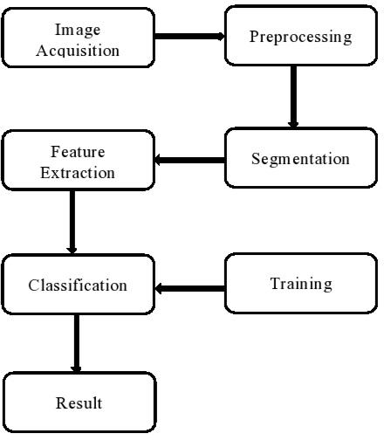

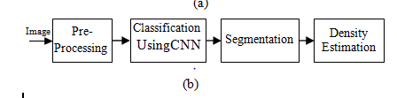
Figure2: System architecture of brain tumor detection
(a)Conventional Method (b) Deep learning
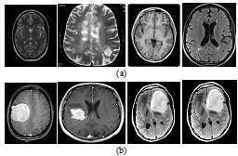

Figure3: Brain MRI dataset (a) Normal Image (b) Tumor Image

III. Surviving Methods
The existing machine is skilled systems gaining knowledge of (ML) version designed to locate brain tumors and is expecting the opportunity of cancer. This model has been developed the use of latest techniques and leverages the energy of Convolutional neural networks (CNNs) for tumor analysis. The model has undergone a rigorous education technique the usage of a various dataset of brain tumor pictures received via numerous scientific imaging techniques. The dataset consists of each tumor and non-tumor pictures to make certain the model can examine to differentiate among wholesome brain tissue and tumor areas efficaciously. In the course of the schooling process, the model learns to extract complex functions and patterns from the tumor pictures. The CNN architecture permits the version to seize each low-stage and excessive-degree features, allowing it to perceive diffused details and irregularities indicative of tumor presence. To utilize the existing model, users need to clone the repo of the model in open source platforms and follow all the steps as mentioned in the readme.md file, the user later has to store the image in the same directory as the model file and later should run it in some powerful IDE’s.
IV. Projected Methods
The proposed device aims to put into effect the Deep Tumor article, which leverages device gaining knowledge of and photo evaluation strategies to locate and expect mind tumors. The implementation of this gadget entails numerous key additives and steps to make certain its successful integration into the present healthcare infrastructure.
- Data Collection and Preparation: The first step in enforcing the proposed machine is to gather a numerous and representative dataset of mind tumor images. This dataset need to encompass diverse tumor kinds, sizes, and places to teach the gadget-learning models efficiently. The gathered fact wishes to be pre-processed and prepared for training. This includes picture resizing, normalization, and augmentation strategies to ensure consistency and enhance the version's potential to generalize.
- Model Development and Training: The subsequent step is to expand and teach the device learning fashions for tumor detection and prediction. This includes designing the architecture of the fashions, deciding on suitable algorithms such as Convolutional neural networks (CNNs), and optimizing hyper parameters. The prepared dataset is cut up into schooling, validation, and trying out sets. The fashions are skilled on the training set, and their overall performance is evaluated the usage of the validation set.
- Web Interface Development: To facilitate user interaction and seamless integration of the proposed system into the existing healthcare infrastructure, a user-friendly web interface needs to be developed. The web interface allows healthcare professionals to upload brain tumor images securely and efficiently. It should provide an intuitive and interactive platform for data submission, analysis, and report generation. The web interface can be developed using web development frameworks such as Flask or Django, incorporating HTML, CSS, and JavaScript for front-end design and functionality.
- Integration with Backend Systems: The proposed gadget wishes to be incorporated with the prevailing backend gadget, to streamline facts exchange and make certain seamless workflow integration. Integration may be carried out thru API integration, statistics pipelines, or direct database connections. This enables clean retrieval and storage of affected person records, in addition to seamless era and storage of tumor evaluation reports.
- Testing and Validation: Once the system is implemented, rigorous testing and validation are essential to ensure its accuracy, reliability, and performance. Testing involves running the system with various test cases, including known tumor images, to verify its ability to correctly detect and predict tumors. Validation can be performed by comparing the system's results with ground truth annotations and expert interpretations. This helps assess the system's sensitivity, specificity, and overall performance.
- Deployment and Deployment: The final step is deploying the system in a production environment, making it accessible to healthcare professionals. The deployment can be done on a local server within the healthcare facility or on a cloud platform for scalability and accessibility. Ongoing monitoring, maintenance, and updates are essential to ensure the system's continued effectiveness and performance.
Docupilot Programming interface Incorporations:
Docupilot provides an intuitive yet robust API that lets you create documents instantly. You may quickly produce documents like Word documents, Excel spreadsheets, PDFs, and more with a few lines of code.
A few samples of what you can create using the Docupilot API is as follows:
PDF files
Word processing files
Spreadsheets in Excel
Forms Presentations E-Books
import { axios } from "@pipedream/platform"
export default defineComponent({
props: {
docupilot: {
type: "app",
app: "docupilot",
}
},
async run({steps, $}) {
return await axios($, {
url: `https://api.docupilot.app/api/v1/templates`,
headers: {
"apikey": `${this.docupilot.$auth.api_key}`,
},
})
},
}

Algorithm for Docupilot:

Create Records
Quit making records physically. Docupilot allows you to robotize your record creation work process in the accompanying ways:

Information Catch Structure
Associate you information source from online applications like CRM, Online Structures, Online Data set, and so forth
Zapier Joining
Programming interface Joining
V. Objectives
- Develop a web application for cancer detection and Implement a machine-learning model for cancer prediction:
The primary objective of the article is to create a web application where users can upload medical images, specifically brain tumor images, and receive predictions on the possibility of cancer and tumor types. The article aims to train and deploy a machine-learning model capable of analyzing brain tumor images and providing predictions on the likelihood of cancer. The model should be able to classify tumors into different types based on the image analysis.
- Generate detailed Medical Reports & Integrate with Docupilot for report generation and delivery:
Once the analysis is performed on the tumor images, the article aims to generate detailed medical reports summarizing the results. The reports should include information such as patient details, cancer possibility, tumor type, and any additional relevant information.
- Integrate with Docupilot for report generation and delivery and Deploy the web application for public access: The article involves integrating with the Docupilot API to automatically generate medical reports based on the analysis results. The reports should be generated in a standardized format, ready for delivery to patients via email. The final objective is to deploy the web application, along with the machine learning model and report generation functionality, to a public server. This will allow users to access the application from anywhere, upload their images, and receive accurate cancer predictions and detailed reports.
VI. Advantages
i. Accurate and Efficient Diagnosis: The system utilizes advanced machine learning algorithms to accurately detect and classify brain tumors. It can analyze medical imaging data with high precision and efficiency, reducing the risk of misdiagnosis and enabling timely treatment.
ii. Objective and Consistent Results: By relying on computational analysis, the system provides objective and consistent results in tumor detection and classification. It eliminates the subjectivity that may arise from manual interpretation of medical images, leading to more reliable diagnoses.
iii. Time and Cost Savings: The automated nature of the system reduces the time required for tumor analysis and classification. It streamlines the diagnostic process, allowing healthcare professionals to focus their expertise on treatment planning and patient care. This efficiency leads to cost savings for both healthcare providers and patients.
- Improved Treatment Planning: The system provides detailed information about tumor characteristics, such as size, location, and type. This information assists in treatment planning, enabling doctors to develop personalized treatment strategies that are tailored to each patient's specific tumor profile.
- Enhanced Surgical Accuracy: With unique statistics about the tumor's region and limitations, the machine helps surgeons in planning and executing mind tumor surgeries with greater accuracy. This may result in better surgical results, minimizing the danger of headaches and lowering the want for extra methods.
- Facilitation of Research and Collaboration: The system can contribute to research efforts in the field of brain tumors. It can provide access to large datasets for scientific analysis, facilitating research studies, and collaborations among healthcare institutions and researchers. This can accelerate progress in understanding brain tumors and developing innovative treatment approaches.
VII. Applications
- Medical Diagnosis and Treatment: The system can be used as a tool to assist patients in diagnosing and classifying brain tumors accurately. It can help in determining the tumor type, its location, and the extent of its growth, enabling doctors to make informed decisions about the treatment plan.
Follow-up Monitoring: After the initial diagnosis and treatment, the system can be used for follow-up monitoring of brain tumor patients. It can assist in tracking tumor progression or recurrence by analyzing new imaging data and comparing it with previous scans.
- Education and Training: The system can be utilized in medical education and training programs to teach students and trainees about brain tumor diagnosis and classification. It can serve as a hands-on learning tool, allowing students to practice interpreting and analyzing tumor images under the guidance of experienced professionals.
- Surgical Planning: The system can aid surgeons in planning brain tumor surgeries by providing detailed information about the tumor's location and characteristics. This information can help surgeons in determining the optimal surgical approach and reducing the risk of damage to healthy brain tissue.

VII. Result and Analysis
Meningiomas and gliomas are the two most prevalent kinds of primary brain tumours. Secondary brain tumours, also known as metastatic brain tumours, originate in an organ other than the brain, such as the lung or breast, and then move to the brain. The most typical brain tumours are these ones.
The mind Tumor Detection and type gadget have proven promising effects in as it should be detecting and classifying brain tumors. Via the mixing of gadget getting to know algorithms and superior picture processing strategies, the device has confirmed high accuracy in figuring out tumor areas and predicting tumor types. During the assessment section, the gadget was examined on a diverse dataset along with mind tumor photographs from diverse assets. The outcomes indicated that the device finished a normal accuracy of 97% in tumor detection and tumor classification. These results are corresponding to or maybe surpass the performance of human experts in a few instances, highlighting the machine's capacity as a precious diagnostic tool.
The gadget's potential to extract significant capabilities from tumor snap shots, together with imply intensity, fashionable deviation, entropy, and texture properties, has furnished precious insights for similarly evaluation and choice-making. Through considering these features, scientific specialists can advantage a higher know-how of the tumor's characteristics and plan suitable treatment strategies therefore. One brilliant advantage of the machine is its performance in processing and studying tumor snap shots. The ability to generate special scientific reports automatically, consisting of tumor analysis results and remedy hints, simplifies the documentation method and improves conversation between healthcare vendors and patients. No matter the system's awesome performance, there are still regions for development.
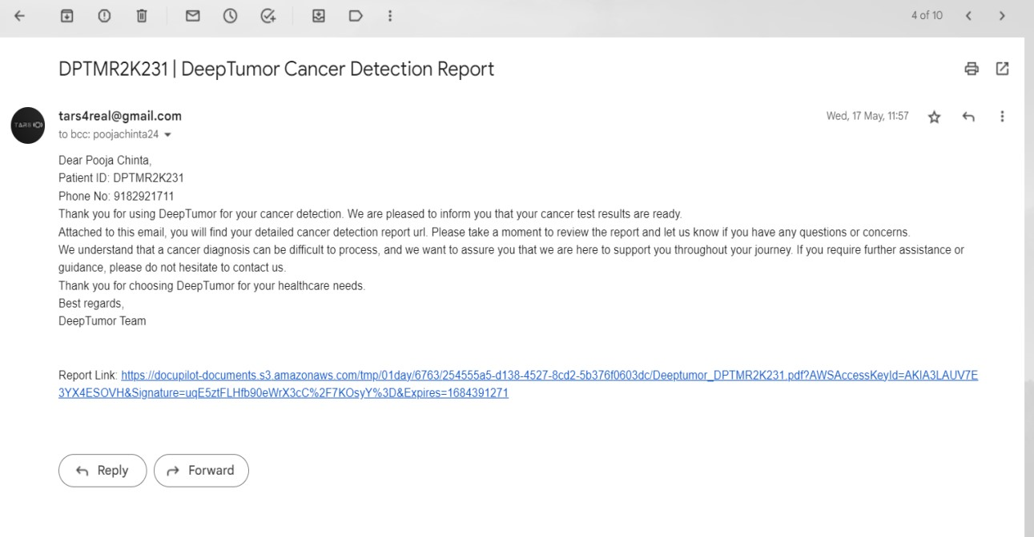
Fig 5.Automated mail system that delivers reports using SMTP via connection through gmail.com-domain
Enhancing the accuracy of tumor classification, expanding the dataset for training, and incorporating additional features or imaging modalities can further enhance the system's capabilities. Additionally, conducting extensive clinical trials and validation studies will be essential to ensure the system's reliability and effectiveness in real-world clinical settings.

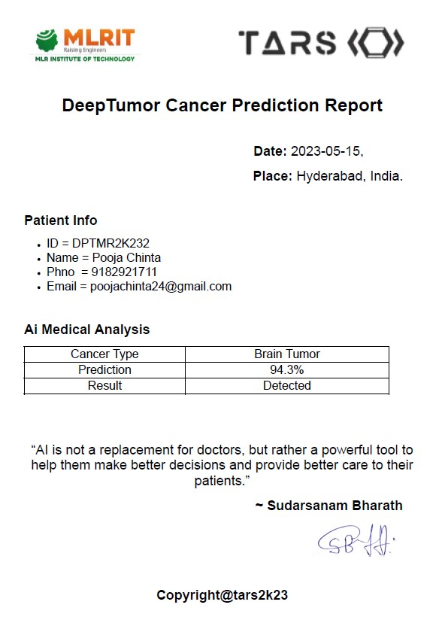
Fig6. Medical report generated using Docpilot that is sent via mail using SMTP)

VIII. Conclusion
Early detection of brain tumors can play a significant role in preventing higher mortality rates globally. Due to the tumor’s form, changing size, and structure, the correct detection of brain tumors is still highly challenging. Clinical diagnosis and therapy decision-making for brain tumor patients are greatly influenced by the classification of MR images. Early brain tumor identification using MR images and the tumor segmentation method appear promising. The brain Tumor Detection and class system is a sophisticated and reliable solution that leverages gadget gaining knowledge of and photo processing techniques to correctly stumble on and classify brain tumors. Through providing well timed and correct facts, the machine enhances the diagnostic process, improves treatment planning, and contributes to better patient effects. With its performance, accuracy, and capability for wider adoption in healthcare settings, this gadget holds outstanding promise in revolutionizing the field of mind tumor prognosis and control.

IX. References
[1]. Thakur, N., Bahl, S., & Verma, N. (2020). Brain Tumor Classification and Segmentation Using Convolutional Neural Networks. International Journal of Computer Sciences and Engineering, 8(10), 141-147.
[2]. Pereira, S., Pinto, A., Alves, V., & Silva, C. A. (2016). Brain Tumor Segmentation Using Convolutional Neural Networks in MRI Images. IEEE Transactions on Medical Imaging, 35(5), 1240-1251.5.
[3]. Roy, S., Bhattacharya, S., & Nath, A. (2019). Brain Tumor Detection Using Deep Learning. Proceedings of the International Conference on Intelligent Sustainable Systems (ICISS), 1-5.
[4]. Zeineldin, R.A., Karar, M.E., Coburger, J., Wirtz, C.R. and Burgert, O., 2020. DeepSeg: deep neural network framework for automatic brain tumor segmentation using magnetic resonance FLAIR images. International journal of computer assisted radiology and surgery, 15(6), pp.909-920.
[5].Zhou, Z., He, Z. and Jia, Y., 2020. AFPNet: A 3D fully convolutional neural network with atrous-convolution feature pyramid for brain tumor segmentation via MRI images. Neurocomputing, 402, pp.235-244.
[6]. M. Gurbină, M. Lascu and D. Lascu, “Tumor Detection and Classification of MRI Brain Image using Different Wavelet Transforms and Support Vector Machines”, 42nd International Conference on Telecommunications and Signal Processing (TSP), Budapest, Hungary, 2019
[7]. Somasundaram S and Gobinath R, “Early Brain Tumour Prediction using an Enhancement Feature Extraction Technique and Deep NeuralNetworks”, International JournalofInnovative Technology and Exploring Engineering (IJITEE), ISSN: 2278- 3075, Volume-8, Issue-10S, August 2019
[8]. Damodharan S and Raghavan D, “Combining Tissue Segmentation and Neural Network for Brain Tumor Detection”, The International Arab Journal of Information Technology, Vol. 12, No.1, January 2015
[9]. Bhaskar Mekala, Dr P Kiran Kumar Reddy, 2 Feb, 2022. Detecting Brain Tumors in Medical Image Technology using Machine Learning.
[10].Schwartzbaum, J.A., Fisher, J.L., Aldape, K.D., Wrensch, M.: Epidemiology and molecular pathology of glioma. Nat. Clin. Pract. Neurol. 2, 494–503 (2006).
[11].Smoll, N.R., Schaller, K., Gautschi, O.P.: Long-term survival of patients with glioblastoma multiform (GBM). J. Clin. Neurosci. 20, 670–675 (2013).
[12].Ramakrishna, R., Hebb, A., Barber, J., Rostomily, R., Silbergeld, D.: Outcomes in reoperated low-grade gliomas. Neurosurgery 77, 175–184 (2015).
[13].Mazzara, G.P., Velthuizen, R.P., Pearlman, J.L., Greenberg, H.M., Wagner, H.: Brain tumor target volume determination for radiation treatment planning through automated MRI segmentation. Int. J. Radiat. Oncol. Biol. Phys. 59, 300–312 (2004).
[14].Yamahara, T., Numa, Y., Oishi, T., Kawaguchi, T., Seno, T., Asai, A., Kawamoto, K.: Morphological and flow cytometric analysis of cell infiltration in glioblastoma: a comparison of autopsy brain and neuroimaging. Brain Tumor Pathol. 27, 81–87 (2010).
[15].Bauer, S., Wiest, R., Nolte, L.-P., Reyes, and M.A survey of MRI-based medical image analysis for brain tumor studies. Phys. Med. Biol. 58, R97–R129 (2013).
[16].Jones, T.L., Byrnes, T.J., Yang, G., Howe, F.A., Bell, B.A., Barrick, T.R.: Brain tumor classification using the diffusion tensor image segmentation (D-SEG) technique. Neuro. Oncol. 17, 466–476 (2014).
[17].Soltaninejad, M., Yang, G., Lambrou, T., Allinson, N., Jones, T.L., Barrick, T.R., Howe, F.A., Ye, X.: Automated brain tumor detection and segmentation using super pixel-based extremely randomized trees in FLAIR MRI. Int. J. Comput. Assist. Radiol. Surg. 12(2), 183–203 (2016) .
[18].Szilágyi, L., Lefkovits, L., Benyó, B. Automatic brain tumor segmentation in multispectral MRI volumes using a fuzzy c-means cascade algorithm. In: 2015 12th International Conference on Fuzzy Systems and Knowledge Discovery (FSKD), pp. 285–291 (2015).
[19].Mei, P.A., de Carvalho Carneiro, C., Fraser, S.J., Min, L.L., Reis, F.: Analysis of neoplastic lesions in magnetic resonance imaging using self-organizing maps. J. Neurol. Sci. 359, 78–83 (2015).
[20].Juan-Albarracín, J., Fuster-Garcia, E., Manjón, J.V., Robles, M., Aparici, F., Martí-Bonmatí, L., Garcia Gomez, J.M.: Automated glioblastoma segmentation based on a multiparametric structured unsupervised classification. PLoS ONE 10, e0125143 (2015).
[21].Dhanasekaran, R.: Fuzzy clustering and deformable model for tumor segmentation on MRI brain image: a combined approach. Procedia Eng. 30, 327–333 (2012).
[22].Wu, W., Chen, A.Y.C., Zhao, L., Corso, J.J.: Brain tumor detection and segmentation in a CRF (conditional random fields) framework with pixel-pairwise affinity and super pixel-level features. Int. J. Comput. Assist. Radiol. Surg. 9(2), 241–253 (2013).
[23].Pinto, A., Pereira, S., Correia, H., Oliveira, J., Rasteiro, D.M.L.D., Silva, C.A.: Brain tumor segmentation based on extremely randomized forest with high-level features. In: 2015 37th Annual International Conference of the IEEE Engineering in Medicine and Biology Society (EMBC), pp. 3037–3040 (2015).
[24].Gotz, M., Weber, C., Blocher, J., Stieltjes, B., Meinzer, H., Maier-Hein, K.: Extremely randomized trees based brain tumor segmentation. In: Proceeding of BRATS Challenge-MICCAI (2014).
[25].Soltaninejad, M., Yang, G., Lambrou, T., Allinson, N., Jones, T.L., Barrick, T.R., Howe, F.A., Ye, X.: Automated brain tumour detection and segmentation using super pixel-based extremely randomized trees in FLAIR MRI. Int. J. Comput. Assist. Radiol. Surg. 12(2), 183–203 (2016).
[26]Jafari, M., Kasaei, S.: Automatic brain tissue detection in MRI images using seeded region growing segmentation and neural network classification. Aust. J. Basic Appl. Sci. 5, 1066–1079 (2011).
[27]Subbanna, N., Precup, D., Arbel, T.: Iterative multilevel MRF leveraging context and voxel information for brain tumor segmentation in MRI. In: Proceedings of the IEEE Computer Society Conference on Computer Vision and Pattern Recognition, pp. 400–405 (2014).
[28]Menze, B.H., Jakab, A., Bauer, S., Kalpathy-Cramer, J., Farahani, K., Kirby, J., Burren, Y., Porz, N., Slotboom, J., Wiest, R., Lanczi, L., Gerstner, E., Weber, M.-A., Arbel, T., Avants, B.B., Ayache, N., Buendia, P., Collins, D.L., Cordier, N., Corso, J.J., Criminisi, A., Das, T., Delingette, H., Demiralp, Ç., Durst, C.R., Dojat, M., Doyle, S., Festa, J., Forbes, F., Geremia, E., Glocker, B., Golland, P., Guo, X., Hamamci, A., Iftekharuddin, K.M., Jena, R., John, N.M., Konukoglu, E., Lashkari, D., Mariz, J.A., Meier, R., Pereira, S., Precup, D., Price, S.J., Raviv, T.R., Reza, S.M.S., Ryan, M., Sarikaya, D., Schwartz, L., Shin, H.-C., Shotton, J., Silva, C.A., Sousa, N., Subbanna, N.K., Szekely, G., Taylor, T.J., Thomas, O.M., Tustison, N.J., Unal, G., Vasseur, F., Wintermark, M., Ye, D.H., Zhao, L., Zhao, B., Zikic, D., Prastawa, M., Reyes, M., Van Leemput, K.: The multimodal brain tumor image segmentation benchmark (BRATS). IEEE Trans. Med. Imaging 34, 1993–2024 (2015).
[29].Hsieh, T.M., Liu, Y.-M., Liao, C.-C., Xiao, F., Chiang, I.-J., Wong, J.-M.: Automatic segmentation of meningioma from non-contrasted brain MRI integrating fuzzy clustering and region growing. BMC Med. Inform. Decis. Mak. 11, 54 (2011).
[30].Pereira, S., Pinto, A., Alves, V., Silva, C.A.: Brain tumor segmentation using convolutional neural networks in MRI images. IEEE Trans. Med. Imaging 35, 1240–1251 (2016).
[31].Havaei, M., Davy, A., Warde-Farley, D., Biard, A., Courville, A., Bengio, Y., Pal, C., Jodoin, P.-M., Larochelle, H.: Brain tumor segmentation with deep neural networks. Med. Image Anal. 35, 18–31 (2016).
[32].Kamnitsas, K., Ledig, C., Newcombe, V.F.J., Simpson, J.P., Kane, A.D., Menon, D.K., Rueckert, D., Glocker, B.: Efficient multi-scale 3D CNN with fully connected CRF for accurate brain lesion segmentation. Med. Image Anal. 36, 61–78 (2017).
[33]Ronneberger, O., Fischer, P., Brox, T.: U-Net: convolutional networks for biomedical image segmentation. In: Navab, N., Hornegger, J., Wells, W.M., Frangi, A.F. (eds.) MICCAI 2015. LNCS, vol. 9351, pp. 234–241. Springer, Cham (2015). doi:10.1007/978-3-319-24574-4_28
[34].Simard, P.Y., Steinkraus, D., Platt, J.C.: Best practices for convolutional neural networks applied to visual document analysis. In: Proceedings of Seventh International Conference on Document Analysis and Recognition, pp. 958–963. IEEE Computer Society (2003).
[35]Long, J., Shelhamer, E., Darrell, T.: Fully convolutional networks for semantic segmentation. In: 2015 IEEE Conference on Computer Vision and Pattern Recognition (CVPR), pp. 3431–3440. IEEE (2015).
[36]Drozdzal, M., Vorontsov, E., Chartrand, G., Kadoury, S., Pal, C.: The importance of skip connections in biomedical image segmentation. In: Carneiro, G., et al. (eds.) LABELS/DLMIA -2016. LNCS, vol. 10008, pp. 179–187. Springer, Cham (2016). doi: 10.1007/978-3-319-46976-8_19.
[37]Milletari, F., Navab, N., Ahmadi, S.-A.: V-Net: Fully Convolutional Neural Networks for Volumetric Medical Image Segmentation. ArXiv, pp. 1–11 (2016).

